Christoph Grab's REFLECTIONS
"Live at Haberhaus" (Lamento Records, 2020)

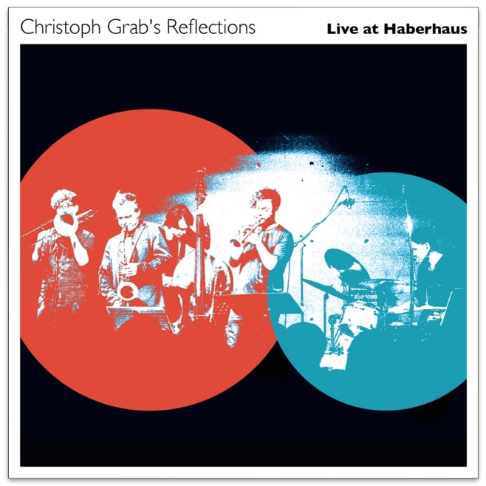
Play your own way - a genius is the one most like himself! (Thelonious Monk)

After my first REFLECTIONS album, released in 2017, and countless concerts, I wanted to expand the trio formation by two wind players and arrange new music for them. The basis remains the music of the jazz visionary Thelonious Monk, one of the most original and inspiring composers of jazz, who has managed to combine tradition and modernity. I bring Monk's compositions into my arrangements in a whole new light without compromising their simplicity and at the same time create new "vehicles" that form the basis for the band's improvisations.
The core of my REFLECTIONS project from the very beginning was the critical-creative dialogue with the music of Thelonious Monk and the confrontation of this music with contemporary improvisers, who can use their personal language to create something new at every concert.

Big Monk

After almost twenty concerts with the trio (with Lukas Traxel on bass and Pius Baschnagel on drums) I engaged with Lukas Thöni (trumpet) and Andreas Tschopp (trombone) two friends, who also try to avoid clichéd licks in their improvisations. In my arrangements I try to transfer the unorthodox chord and cluster language of Monk to the 3-piece wind section. In doing so, I continue to take over Monk's pieces generally not 1:1, but give them their own spin, which should inspire the band and lead them out of the familiar. With all this I hope to be able to show that something new and unheard can also be created on the basis of iconic material out of jazz history.

The new album has been recorded live: This is also a conscious decision to capture the essence of this music - the momentary inventing, communicating and shaping on stage.

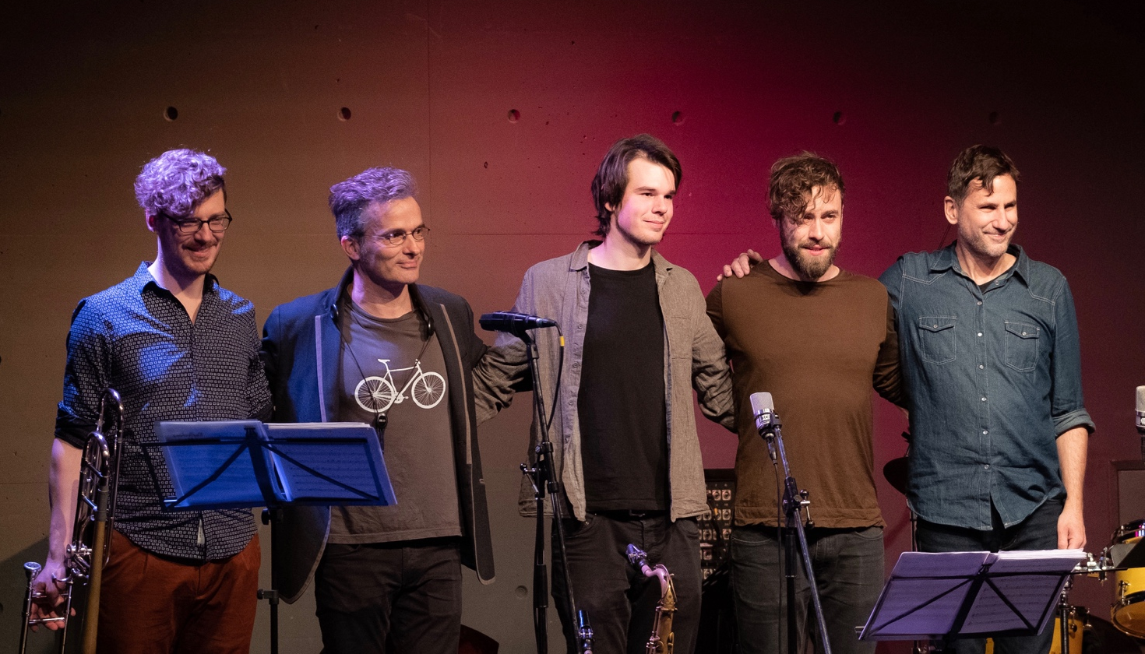

Line-up:
Christoph Grab saxes, Lukas Thoeni trumpet, Andreas Tschopp trombone, Lukas Traxel bass, Pius Baschnagel drums

All compositions by Thelonious Monk, all arrangements by Christoph Grab. Recorded February 9th 2019 live at Haberhaus in Schaffhausen/Switzerland. Recorded and mixed by Maxime Paratte. Coverart & Graphic Design: Nicolas Hadorn. ℗ 2020 Lamento Records. Contact/Info: www.christophgrab.com

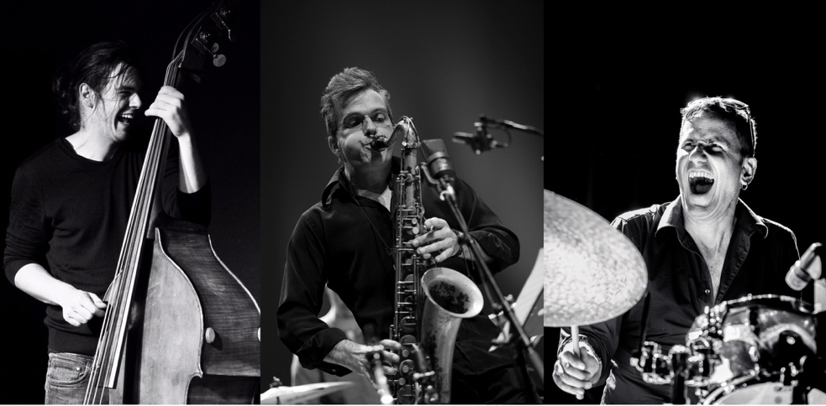

The first album:

Christoph Grab "Reflections" (Lamento Records, 2017)
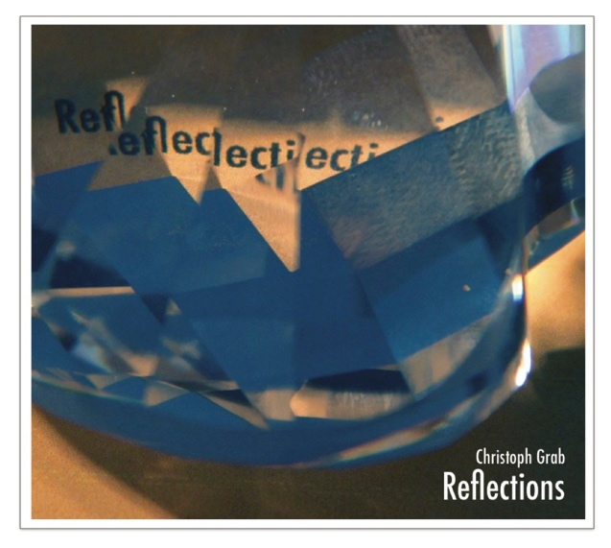

The Trio-Studioalbum "Reflections" from 2017 was very positively reviewed by the international press:

"...a respectful confrontation with Monk's repertoire on the one hand, a vibrant, contemporary album on the other hand."(Jazzthetik")

"The album convinces with empathy, swing and drive. And Christoph Grab's sound palette and phrasing art are a joy in themselves." (NZZ on Sunday)

"An album that pricks up one's ears." (cultural tip)

"The motto of this band is: Vitality instead of cramps! REFLECTIONS neither act as guardians of the Grail nor as conceptual artists, but on the basis of jazz virtues (willingness to take risks, interactive joy of playing, flow) go on the hunt for the fulfilled moment and bring us many wonderful Monk moments." (Tom Gsteiger)

"The trio acts with great understanding among each other and sparkle with joy of playing and innovation"(musikansich.de)

More Infos/Sound/Videos/Pics: https://www.christophgrab.com/de/bands/reflections
Contact: info@christophgrab.com

